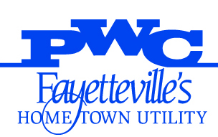
FAYETTEVILLE PUBLIC WORKS COMMISSION
955 OLD WILMINGTON RD
P.O. BOX 1089
FAYETTEVILLE, NORTH CAROLINA 28302-1089
TELEPHONE (910) 483-1401
WWW.FAYPWC.COM

WADE R. FOWLER, JR., COMMISSIONER
EVELYN O. SHAW, COMMISSIONER
RONNA ROWE GARRETT, COMMISSIONER
DONALD L. PORTER, COMMISSIONER
ELAINA L. BALL, CEO/GENERAL MANAGER

July 14, 2022

TO: All Prospective Bidders

FROM: Trent Ensley, Procurement Manager

SUBJECT: ADDENDUM NO. 2
PWC2122055 – RE-ADVERTISEMENT FOR SHADOWLAWN AERIAL SEWER CROSSING REPLACEMENT

- The Specifications and Bid Documents are hereby modified or clarified per the attached documents.

- The originally scheduled bid opening failed to produce three (3) bids. The project is now re-advertised with a new bid opening date of July 22, 2022, at 10:30 am at the originally scheduled location:
PWC Administration Building
955 Old Wilmington Road, Fayetteville, NC 28301
Outside by the entrance doors.

- The foregoing changes or clarifications shall be incorporated in the original Bid Documents and a signed copy of this Addendum No. 2 shall accompany the bid to acknowledge the bidder’s receipt and familiarly with the changes and/or clarifications.

TE:tke

Acknowledgement:

Company

By

Date

